Preconception Health & Wellbeing: Spotlight on Alcohol
Wednesday 16th September 2.30pm – 3.45pm (Online via Teams).
Free event
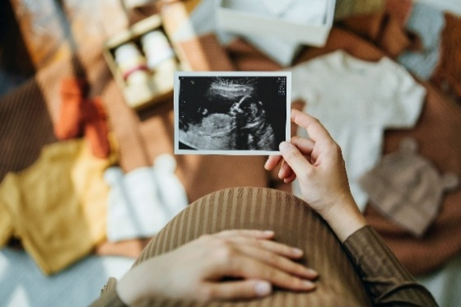
Purpose
Preconception health has a vital role in ensuring the best start in life for infants and the best outcomes for mothers and families. There are many opportunities before pregnancy (including for young people, for those actively planning a pregnancy, and for those between pregnancies) to improve health and to reduce inequalities. Many factors influence preconception health, including wider determinants of health, health-related behaviours and medical conditions, making it a theme that cuts across multiple organisational and programme boundaries.
With alcohol as a key modifiable factor that impacts health outcomes in mothers and infants, public health teams and wider colleagues in the North West and South West regions have collaborated to present a spotlight session on alcohol in the preconception and interpregnancy period.
Objectives
To understand
- The problems associated with drinking alcohol in pregnancy, with a focus on Foetal Alcohol Spectrum Disorder (FASD) and its impact on development
- Current services and support
- The importance of the preconception & interpregnancy periods as opportunities for intervention for key groups
- Data from the North West and South West and new research on the prevalence of alcohol consumption in pregnancy
- The evidence and advice about no- and low- alcohol drinks (NoLos) in pregnancy

To share examples of good practice:
- The ‘Drymester’ awareness-raising campaign and workforce training resources in Greater Manchester
- Research-informed Maternal Alcohol Reduction Interventions (MARI)

To consider opportunities to make every contact count (MECC) and reduce alcohol-related harm for all services who contribute to preconception health.

Who is this for?
Primary care, public health, 0-19 Healthy Child Providers, Local Authority CYP Leads, LA Alcohol Leads, Family Hub Teams, ICB women’s health and population health leads, Midwifery leads, Women’s Health Hub leads, Sexual Health, Neighbourhood Health leads, VCFS and other colleagues who support this important area
Registration
To register for this event please click on the link below: Preconception Spotlight on Health and Alcohol | Join meeting in Teams | Microsoft Teams

