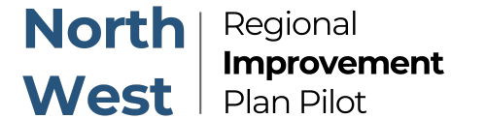
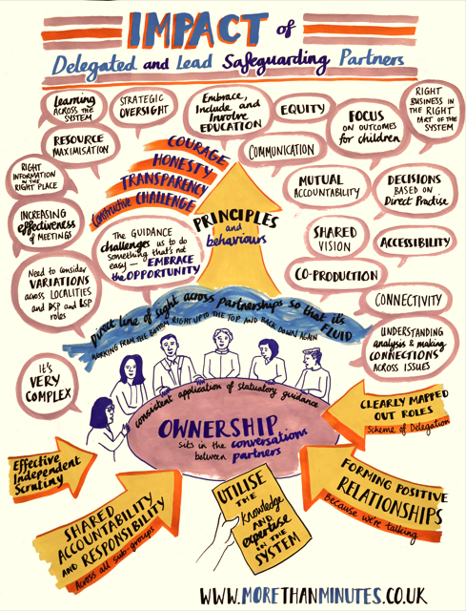

A national child safeguarding practice review has investigated the experience of 193 children who were sexually abused by a family member: National review into child sexual abuse within the family environment - GOV.UK The report reveals that safeguarding agencies were not equipped with the skills and support to listen, hear and protect these children from horrific abuse.

The North West Regional Improvement Pilot Programme (RIPP) are delivering multi-agency training to support the implementation of the pathway and resources in the NW free of charge.


Free training webinars

The Response Pathway – 28th April or 13th May 2025
(1pm – 2pm or 10am – 11am)
This one-hour webinar will help professionals learn how to start using the Child Sexual Abuse Response Pathway | CSA Centre in practice, and empower them to understand the role they, and their colleagues, can play to best protect and support children. The session gives advice and examples of how to use the Response Pathway and explains how it supports professionals to meet the needs of children and their families.
To book onto the 28th April 2025 session, click here
To book onto the 13th May 2025 session, click here

Spotting the signs and indicators of child sexual abuse – 21st May or 10th June 2025
(9.30am – 10.20am or 10am – 11am)
This one-hour webinar will introduce professionals to the Signs and Indicators Template and give an opportunity to use it in practice. It aims to give professionals working with children the knowledge and confidence to act when they are concerned about a child.
Further information and to book a place on 21st May – click here
To book onto 10th June 2025 session – click here

Communicating with children about sexual abuse – 11th June or 7th July 2025
(10am – 11am or 10.30am – 11.30am)
This one-hour webinar aims to help professionals understand what they can do to help children by putting our Communicating-with-children-guide.pdf into practice. In this session we will explain what may be going on for children when they are being sexually abused, what prevents them from talking about their abuse, and what professionals can do to help children speak about what is happening.
For more information and to book a place for 11th June session – click here
To book onto 7th July session – click here

Supporting parents and carers when their child has been sexually abused – 15th July or 9th September 2025
(10.30am – 11.30am)
This one-hour webinar aims to help professionals understand what they can do to support parents / carers by putting our Supporting parents and carers guide into practice. This webinar hopes to guide your thinking in supporting parents and carers of any age, including those with special education needs.
To book onto 15th July session – click here
To book onto 9th September session – click here

Responding to harmful sexual behaviour in education settings – 8th July or 15th September 2025
(4pm – 5pm)
This one-hour webinar aims to help give professionals the knowledge and confidence to act, using the CSA Centre’s Safety planning in education: A guide for professionals supporting children following incidents of harmful sexual behaviour. This guide supports your thinking in supporting children of any age, including those with special education needs, following incidents of harmful sexual behaviour.
To book onto 8th July session – click here
To book onto 15th September session – click here

