# Upcoming Changes to EYFS Safeguarding Requirements – Effective September 2025

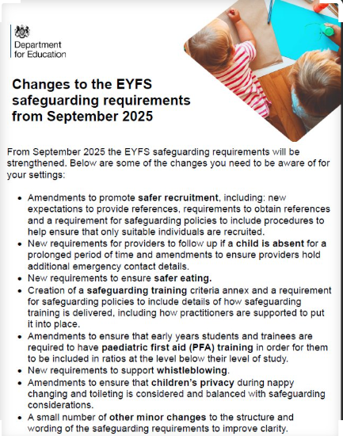

**Upcoming Changes to EYFS Safeguarding Requirements – Effective September 2025**

From September 2025, the safeguarding requirements within the Early Years Foundation Stage (EYFS) will be strengthened to further support the safety and wellbeing of children in early years settings. Key updates include:

* **Enhanced Safer Recruitment Practices**  
  Revised guidance to promote more robust recruitment procedures.
* **New Protocols for Child Absence**  
  Providers will be required to follow up on unexplained absences to ensure children's safety.
* **Safer Eating Measures**  
  Introduction of new standards to support safe eating practices in early years settings.
* **Updated Safeguarding Training Requirements**  
  All early years students and trainees must now complete paediatric first aid training.
* **Strengthened Whistleblowing Procedures**  
  New requirements to ensure staff feel supported and confident in reporting concerns.
* **Privacy and Safeguarding in Personal Care**  
  Amendments to ensure children's privacy during nappy changing and toileting is respected, while maintaining safeguarding standards.

For full details and guidance, please visit the UK Government website. [Early years foundation stage (EYFS) safeguarding - GOV.UK](https://www.gov.uk/government/consultations/early-years-foundation-stage-eyfs-safeguarding?utm_source=Klaviyo&utm_medium=email&_kx=8t-MBVtmFnE_cs_zDdd15nq1vHb0q7v1J3-1bywuXFo_eLMPo1zjDSzOgmrMvNkW.SAr7eJ)

Official Guidance from the Department for Education  
View the full list of changes to EYFS safeguarding requirements as outlined by the DfE.

[EYFS statutory framework for group and school-based providers](https://assets.publishing.service.gov.uk/media/687105a381dd8f70f5de3ea9/EYFS_framework_for_group_and_school_based_providers_.pdf)